From Source Text to Creative Production: Technological and Narrative Approaches to Shakespeare Adaptation for Expanded Animation (VR)
（题目：三号字，微软雅黑，单倍行距加粗，加线，居左）
Hannes Rall¹, Emma Harper², Gelissa Loh³ and Jasper Teh³
（作者名字：五号字，新罗马英文字体，1.5倍行距）
¹Professor of Animation Studies and Associate Chair (Research), School of Art, Design and Media Nanyang Technological University, Singapore
²Research Associate, School of Art, Design and Media, Nanyang Technological University, Singapore
³Research Assistant, School of Art, Design and Media, Nanyang Technological University, Singapore
（作者单位：小五号字，新罗马英文字体，1.5倍行距，斜体）
Abstract: This paper focuses on an ongoing project to create an adaptation of the lesser-known Shakespeare play Pericles, Prince of Tyre for animated VR. In exploring this case study, we pay attention to both technical and narrative development outlining how our adaptation has been shaped by interdisciplinary scholarly knowledge, visual concerns, and technological possibilities. However, we argue that it is incorrect to assume that the lack of a fixed screen present in immersive media requires a focus solely on the technical and practical elements of animation production, instead demonstrating that expanded animation requires technological implementation that is fundamentally embedded in issues relating to narrative structure and the enduring unique vocabulary of animation as a medium.
（摘要：五号字，新罗马英文字体，1.5倍行距）
Keywords: virtual reality, expanted animation, adaptation, Shakespeare
（关键词：五号字，新罗马英文字体，1.5倍行距）
1. Introduction（一级标题：小四号字，新罗马英文字体，2倍行距，加粗）
In their discussion of expanded and experimental animation, Smith and Hamlyn highlight a need to consider “how animation can be redefined when it is no longer articulated through the single screen alone,” and how such forms of animation involve a situation in which “traditional or commercial practices are exposed to new critical methodologies or re-workings” ¹. In this paper, we will provide insights into how expanded animation might manifest itself both theoretically and practically through the lens of our ongoing project to adapt Shakespeare’s Pericles, Prince of Tyre for gamified virtual reality (VR). This practice-led-research project is currently at the production stage and is particularly interested in exploring the implications of adapting works of Shakespeare for diverse
types of interactive digital media, and the relationship between narrative elements in the original text and the specific requirements of these media forms. In particular, the project seeks to interrogate how transforming a Shakespearean play into a serious game facilitates a non-linear and interactive approach to storytelling. Funded by the Singapore Ministry of Education (MoE) AcRF Tier 2 grant “From Print to Digital Continued,” the project is also keen to explore how taking an immersive approach to Shakespeare can impact upon students’ engagement with the original text and its meanings.
（正文：五号字，新罗马英文字体，1.5倍行距，段间距：段后一行）
1.1 Environment（二级标题：五号字，新罗马英文字体，1.5倍行距，斜体，加粗）
1.1.1 Modelling and Rigging（三级标题：五号字，新罗马英文字体，1.5倍行距，斜体）
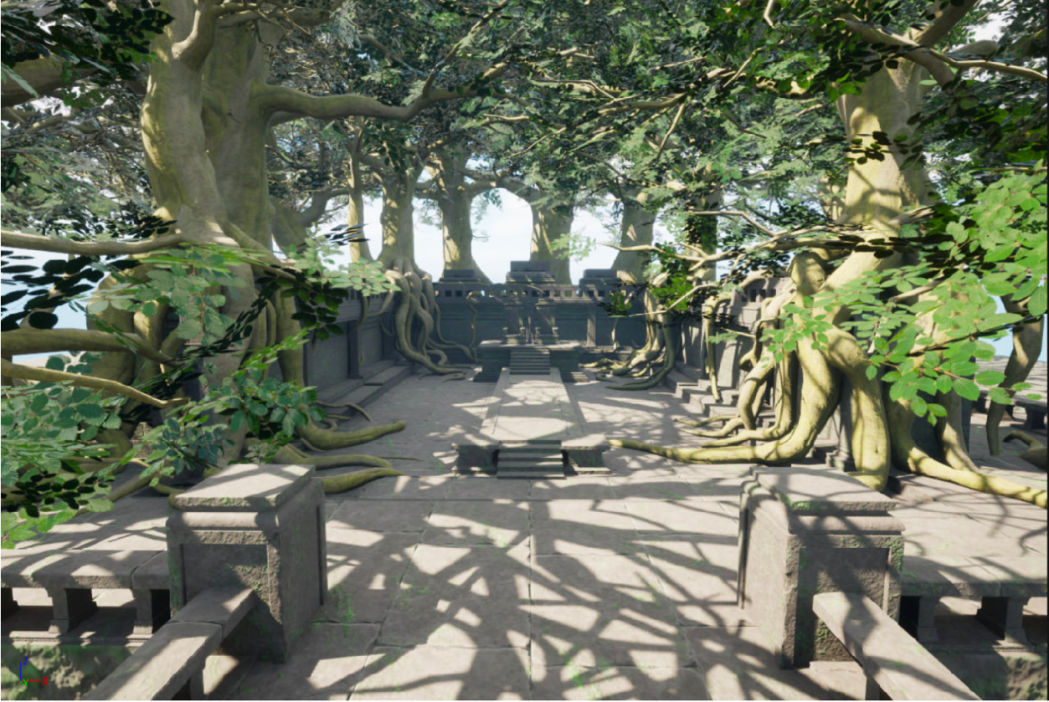
Fig 3. Screengrab from Unreal showing first pass of virtual environment.
（图示：小五号字，新罗马字体，单倍行距）

——————————————————————————————————————————————
This research is supported by the Ministry of Education, Singapore, under AcRF T2 Grant MOE-T2EP40120-003 “From Print to Digital Continued: Expanded Research into adapting Shakespeare for VR, AR and AI.” Any opinions, findings and conclusions or recommendations expressed in this material are those of the authors and do not reflect the views of the Ministry of Education, Singapore.
（注释：小五号字，新罗马英文字体，1.15倍行距，置于当页底部）
REFERENCES
[1] Vicky Smith and Nicky Hamlyn. “Introduction,” in Vicky Smith and Nicky Hamlyn (eds.). Experimental and Expanded Animation: New Perspecctives and Practices. Palgrave Macmillan Cham, 2018, p. 2. doi.org/10.1007/978-3-319-73873-4.
[2] Stephen Wittek and David McInnis. “Introduction,” in Stephen Wittek and David McInnis (eds.). Shakespeare and Virtual Reality. Cambridge Universit
（参考文献：小五号字，新罗马英文字体，1.5倍行距）

请您按照模板格式进行论文排版，如需帮助，请联系编辑部：010-62662716

